A Project report on

**Registrar+**

Submitted to Manipal University, Jaipur

Towards the partial fulfillment for the Award of the Degree of

**BACHELOR OF TECHNOLOGY**

In Computers Science and Engineering

2021-2022

By

Pradumn Garg

199301250



Under the guidance of

Dr. Ankit Srivastava

**Department of Computer Science and Engineering**

**School of Computing and Information Technology**

**Manipal University Jaipur**

**Jaipur, Rajasthan**

**INTRODUCTION**

Registrar+ is a program which helps retail companies to store their data in the form of a register. The data includes employee details, product details ,supplier details , transaction details etc. Most of the companies make use of excel to store this data which isn’t such an efficient method. It would provide the companies to deal with chunks of data and use them efficiently to make decisions regarding the welfare of the organization and enhance their productivity.

**MOTIVATION**

The motivationbehind **Registrar+** is a real world scenario. We ourselves have multiple retail stores in the city . And to store details of each store, we use an excel sheet. It is a really very tedious process to scrutinize each individual employee based on a particular condition. It does waste a lot of productive time and many other details are looked upon which can be very essential for management purposes.

**PROJECT OBJECTIVE**

The primary objective of **Registrar+** is to help retail companies to manage their company data more efficiently. This program will help them to store transaction , employee, product,customer etc. details in a more secured way and retrieve information easily according to their needs which enables them to make decisions pertaining to its welfare easily.

|  |  |  |
| --- | --- | --- |
| Problems | Excel | Registrar+ |
| Data retrieval easier | ❌ | ✅ |
| Easier to analyze | ❌ | ✅ |
| Very Secured | ❌ | ✅ |
| User-friendly | ❌ | ✅ |

|  |  |
| --- | --- |
| PROS | CONS |
| User-friendly | User should be tech-friendly |
| Chunks of data stored with automation | Data maintenance required from time to time |
| Data retrieval faster and easier to analyze |  |
| Data easily altered |  |

**METHODOLOGY AND PLANNING**

A company website would be created using HTML,CSS,JavaScript and Bootstrap . The data would be written in MYSQL and would be queried in according with the requirements of the company. The data would be integrated with the website using PHP and MYSQLi and could be accessed with login credentials so as to be secured.

**GANTT CHART**

* **Week 1:**  General planning to select the project to work on and whether to use an app or website to integrate it
* **Week 2:** Creating the backend end of the website i.e the entity relationship sets, schemas and SQL queries.
* **Week 3:** Building the front end of the website. And integrating the website with the database

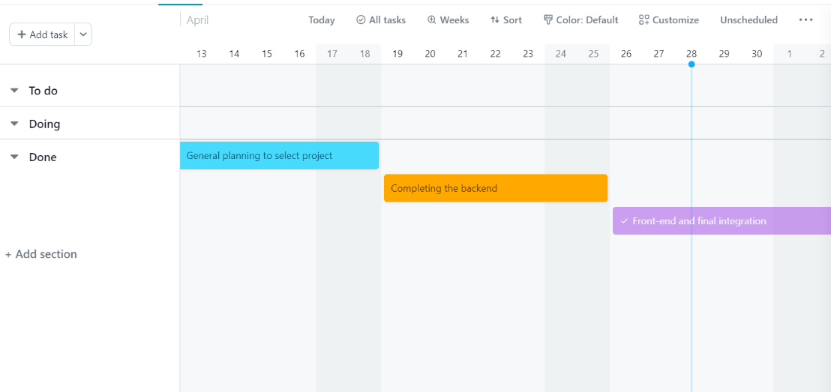

**ENTITY RELATION SHIP DIAGRAM**

**GARG ENTERPRISES WEBSITE**

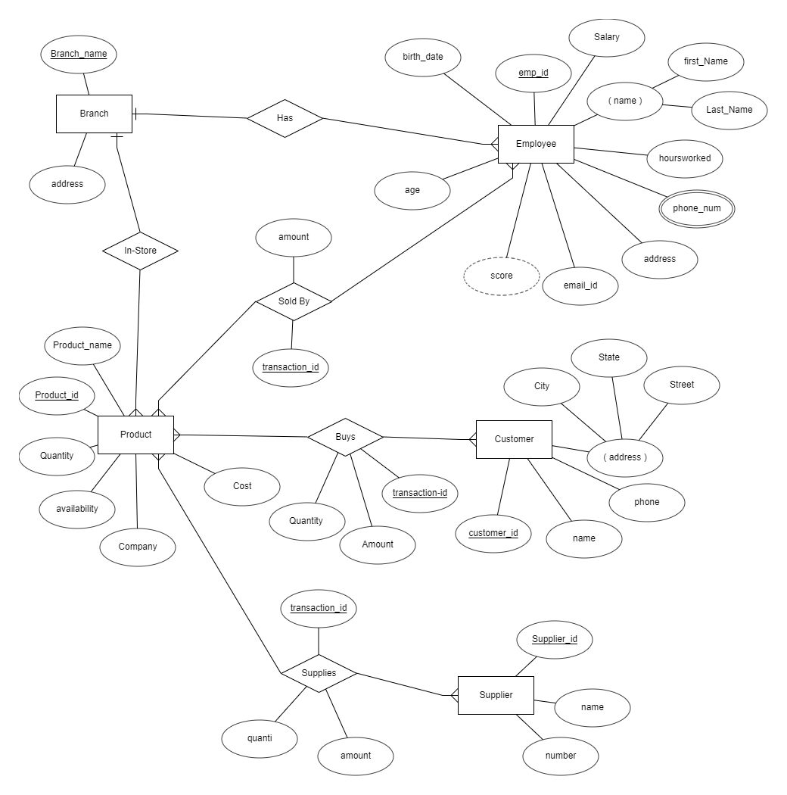

**SOFTWARE AND HARDWARE REQUIREMENTS**

* MYSQL
* CSS
* HTML
* Bootstrap
* JAVASCRIPT
* PHP
* Desktop friendly
* XAMPP
* Canva

**RELATIONAL SCHEMA**

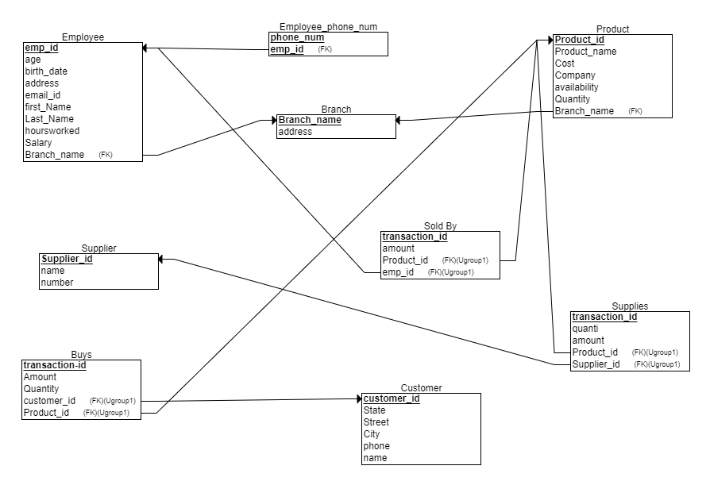

**SQL CODE**

CREATE DATABASE GargEnterprises;

use GargEnterprises;

CREATE TABLE Branch

(

Branch_name varchar(255) NOT NULL,

address varchar(255) NOT NULL,

PRIMARY KEY (Branch_name)

);

CREATE TABLE Product

(

Product_id INT NOT NULL,

Product_name varchar(50) NOT NULL,

Cost INT NOT NULL,

Company varchar(50) NOT NULL,

availability varchar(20) NOT NULL,

Quantity INT NOT NULL,

Branch_name varchar(255) NOT NULL,

PRIMARY KEY (Product_id),

FOREIGN KEY (Branch_name) REFERENCES Branch(Branch_name)

);

CREATE TABLE Supplier

(

Supplier_id INT NOT NULL,

name varchar(50) NOT NULL,

number varchar(15) NOT NULL,

PRIMARY KEY (Supplier_id)

);

CREATE TABLE Customer

(

State varchar(20) NOT NULL,

Street varchar(100) NOT NULL,

City varchar(20) NOT NULL,

phone varchar(15) NOT NULL,

name varchar(20) NOT NULL,

customer_id INT NOT NULL,

PRIMARY KEY (customer_id)

);

CREATE TABLE Supplies

(

quanti INT NOT NULL,

transaction_id INT NOT NULL,

amount INT NOT NULL,

Product_id INT NOT NULL,

Supplier_id INT NOT NULL,

PRIMARY KEY (transaction_id),

FOREIGN KEY (Product_id) REFERENCES Product(Product_id),

FOREIGN KEY (Supplier_id) REFERENCES Supplier(Supplier_id),

UNIQUE (Product_id, Supplier_id)

);

CREATE TABLE Buys

(

transaction_id INT NOT NULL,

Amount INT NOT NULL,

Quantity_ INT NOT NULL,

customer_id INT NOT NULL,

Product_id INT NOT NULL,

PRIMARY KEY (transaction_id),

FOREIGN KEY (customer_id) REFERENCES Customer(customer_id),

FOREIGN KEY (Product_id) REFERENCES Product(Product_id),

UNIQUE (customer_id, Product_id)

);

CREATE TABLE Employee

(

age INT NOT NULL,

emp_id INT NOT NULL,

birth_date date NOT NULL,

address varchar(100) NOT NULL,

email_id varchar(30) NOT NULL,

first_Name varchar(20) NOT NULL,

Last_Name varchar(20) NOT NULL,

hoursworked INT NOT NULL,

Salary INT NOT NULL,

Branch_name varchar(255) NOT NULL,

PRIMARY KEY (emp_id),

FOREIGN KEY (Branch_name) REFERENCES Branch(Branch_name)

);

CREATE TABLE Sold_By

(

transaction_id INT NOT NULL,

amount INT NOT NULL,

Product_id INT NOT NULL,

emp_id INT NOT NULL,

PRIMARY KEY (transaction_id),

FOREIGN KEY (Product_id) REFERENCES Product(Product_id),

FOREIGN KEY (emp_id) REFERENCES Employee(emp_id),

UNIQUE (Product_id, emp_id)

);

CREATE TABLE Employee_phone_num

(

phone_num varchar(15) NOT NULL,

emp_id INT NOT NULL,

PRIMARY KEY (phone_num, emp_id),

FOREIGN KEY (emp_id) REFERENCES Employee(emp_id)

);

insert into branch(

branch_name ,address

)

values(

'Garg Lifestyle','19/4710 cuttack road'

),

(

'Garg Trading Company','Durga Mandap'

);

insert into employee(age,

emp_id ,

birth_date,

address ,

email_id ,

first_Name ,

Last_Name ,

hoursworked ,

Salary ,

Branch_name)

values(25,1,'1995-05-25','kalpana Square','vishnu@gmail.com','vishnu','gupta',330,25000,'Garg Lifestyle'

),

(27,2,'1994-03-27','Louis Road','madhav@gmail.com','madhav','sharma',320,20000,'Garg Lifestyle' ),

(24,3,'1997-02-11','Shaheed Road','sarkar21@gmail.com','sarkar','das',310,7000,'Garg Trading Company');

insert into employee_phone_num(

phone_num,

emp_id)

values('9437010223',1),

('9437010224',1),

('9437010214',2),

('9437010274',3);

insert into product(Product_id ,

Product_name ,

Cost ,

Company,

availability ,

Quantity ,

Branch_name

)

values(1,'silver faucet',27000,'Roca','Yes',50,'Garg Lifestyle'),

(2,'woodbridge bathtub',35000,'kohler','Yes',30,'Garg Lifestyle'

),

(3,'shower part',4000,'Axor','Yes',100,'Garg Trading Company');

insert into customer(State ,

Street ,

City,

phone ,

name ,

customer_id

)

values('Odisha','kalpana square','bhubaneswar','8093345321','Somil Gupta',1),

('odisha','louis road','rourkela','8093345721','Shaleen poddar',2);

insert into supplier(Supplier_id ,

name,

number

)

values(1,'roca India','7577465321'),

(2,'kohler India','7577465521'),

(3,'Axor India','7582465321');

insert into supplies(quanti ,

transaction_id ,

amount ,

Product_id ,

Supplier_id)

values(51,123456789,1377000,1,1),

(31,324571890,1085000,2,2),

(102,208748390,408000,3,3);

insert into buys( transaction_id ,

Amount ,

Quantity_,

customer_id ,

Product_id )

values

(786390287,27000,1,1,1),

(830183762,35000,1,1,2),

(278028738,8000,2,2,3

);

insert into sold_by( transaction_id ,

amount ,

Product_id ,

emp_id

)

values

(786390287,27000,1,1),

(830183762,35000,2,2),

(278028738,8000,3,3

);

**PROJECT REPORT**

**A)DATABASE**

**Tables in the Database:-**

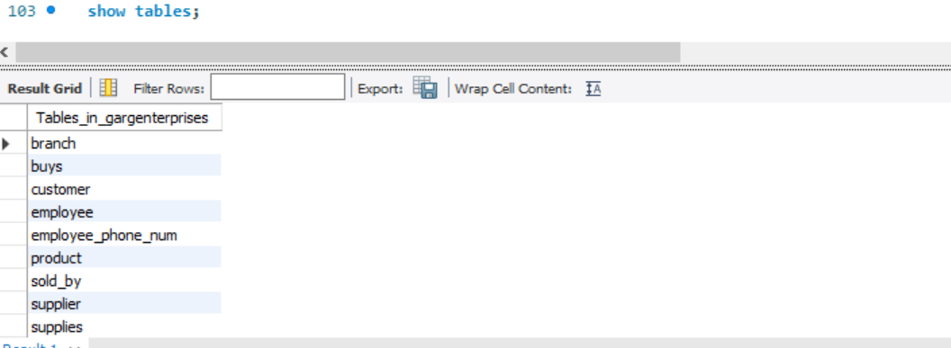

**Brief Description of tables:-**

1. **Branch**

It is a table which tells us which branch of the company has the products and employees as displayed in database.

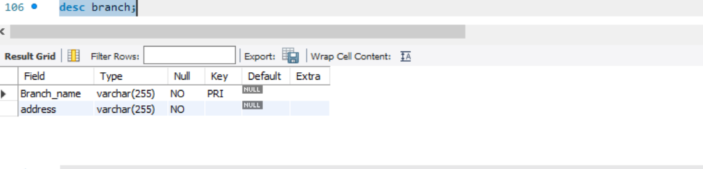

* Branch_name:Primary key of the table
* Address: Stores the address of the branch

Here the table satisfies all normal forms including BCNF. As there are no partial dependencies or transitive dependencies. Multiple values do not exist. Also there exists super key for each.

1. **EMPLOYEE**

It stores all the employee details associated with a particular branch of the company.

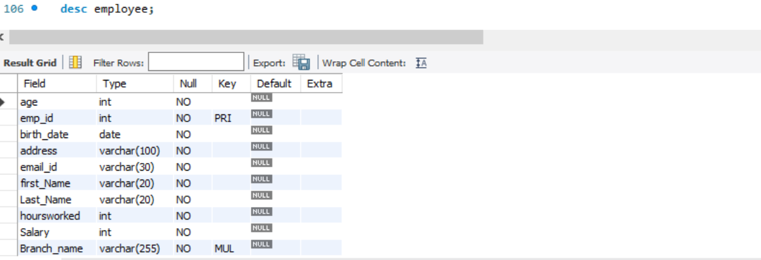

* Emp_id:-primary key of the table
* Age:-age of the employee
* Birth_date;-date of birth
* Address:-address of the employee
* Email-id:-mail id of employee
* First_name,last_name:-name of the employee
* Hoursworked:hours worked by him
* Salary: his salary
* Branch_name:The branch he is associated with . It is a foreign key connecting to branch table

Here the table satisfies all 3NF normal forms. As there are no partial dependencies or transitive dependencies. Multiple values do not exist. Also there exists emp_id which is the candidate key for the table and all non-prime attributes are fully functionally dependent on it.

**3)PRODUCT**

It stores all the product details associated with the branch of the company.

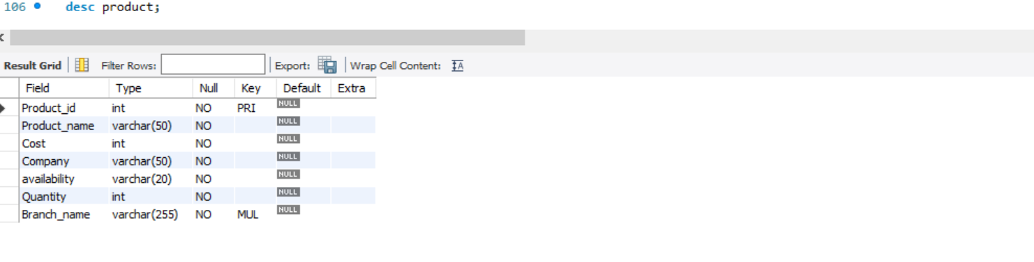

* Product_id : primary key of the table
* Product_name:Name of the product
* Cost:cost of the product
* Company: The brand of the product
* Availability:Whether available or not
* Quantity:Quantity of the product in stock
* Branch_Name:the branch of the company which has the product;forrign key

Here the table satisfies all 3NF normal forms. As there are no partial dependencies or transitive dependencies. Multiple values do not exist. Also there exists product_id which is the candidate key for the table and all non-prime attributes are fully functionally dependent on it.

**4)CUSTOMER**

The table stores the details of the customer.

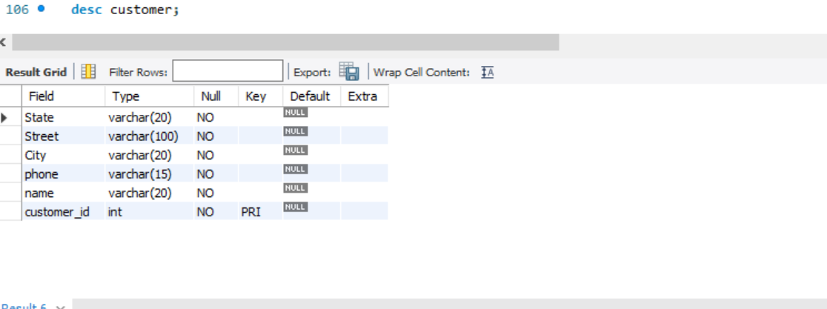

* Customer_id:Primary key of the table
* State:the state to which customer belongs
* Street: his street name
* City:City name
* Phone:Phone number
* Name:his name

Here the table satisfies all 3NF normal forms As there are no partial dependencies or transitive dependencies. Multiple values do not exist. Also there exists customer_id which is the candidate key for the table and all non-prime attributes are functionally dependent on it.Note I had added zip attribute beforehand and it could also uniquely identify the state,city and street but wasn’t required and so was removed.

**5)EMPLOYEE-PHONE-NUM**

It stores the phone-numbers of the employees

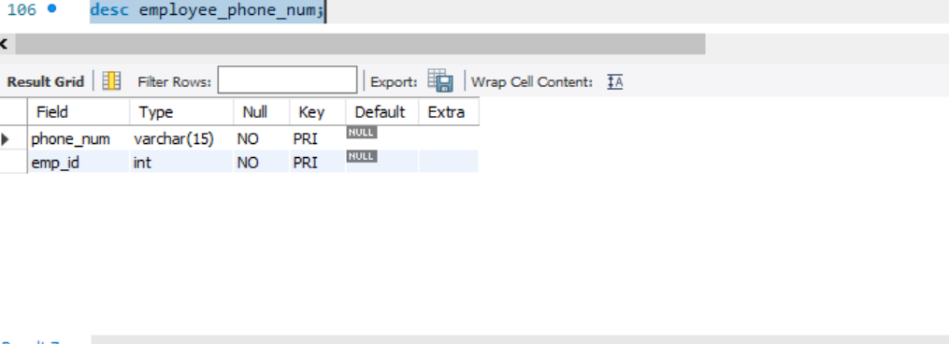

* Phone_number:candidate key
* Emp_id:primary key connecting to employees

Here the table satisfies all 3NF normal forms As there are no partial dependencies or transitive dependencies. Multivalued values do not exist. It was first a multiple attribute of employees and was violating 1NF .So I created another table and mapped it with employee id’s so as to satisfy all normal forms.phone _number and emp_id can uniquely determine all attributes(only attributes present though)

**6)BUYS**

It gives us the transaction details taking place when a customer buys a particular product.

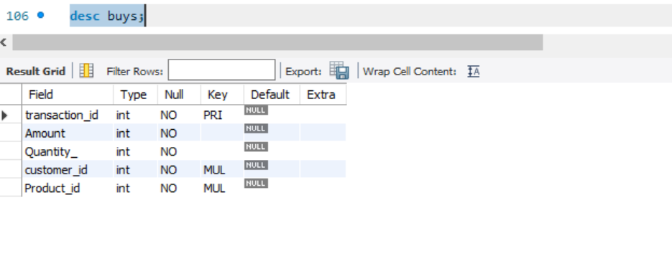

* Transaction_id : primary attribute
* Amount : Amount spent by customer
* Quantity: Quantity of product purchased
* Customer_id :the customer buying the product;foreign key
* Product_id:the product bought by the customer;foreign key

Here the table satisfies all 3NF normal forms As there are no partial dependencies or transitive dependencies. Multiple values do not exist. Also there exists transaction_id which is the candidate key for the table and all non-prime attributes are functionally dependent on it.It maps the customer and product table.

**7)SUPPLIER**

It gives us the deails of supplier who supplies a particular product.

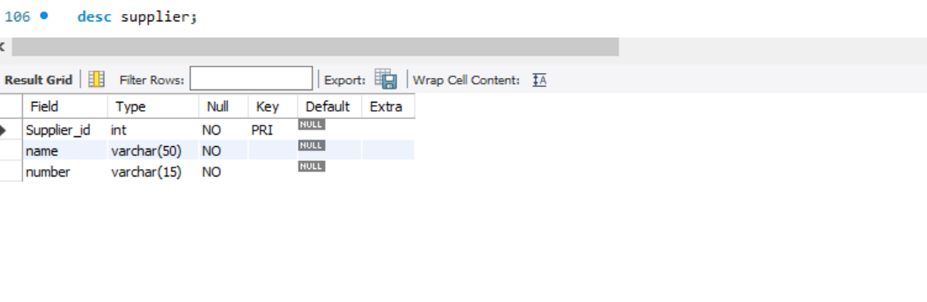

* Supplier_id:primary attribute
* Name:name of supplier
* Number:phone number of supplier

Here the table satisfies the 3NF normal form As there are no partial dependencies or transitive dependencies. Multiple values do not exist. Also there exists supplier_id which is the candidate key for the table and all non-prime attributes are functionally dependent on it.

**8)SUPPLIES**

It tells us which product is supplied by which supplier

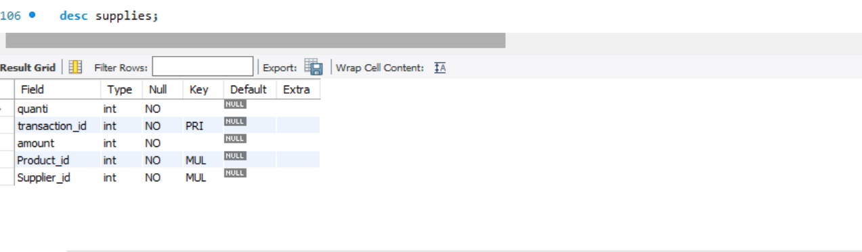

* Transaction_id:primary attribute
* Product_id:the product supplied;foreign key
* Supplier_id:the supplier supplying the product;foreign key
* Amount:the amount of money paid to purchase the product
* Quanti:the quanti of the product supplied

Here the table satisfies the 3NF normal form As there are no partial dependencies or transitive dependencies. Multiple values do not exist. Also there exists transaction_id which is the candidate key for the table and all non-prime attributes are fully functionally dependent on it.

**9)SOLD_BY**

It gives us the details about the employee who sold the product to the customer

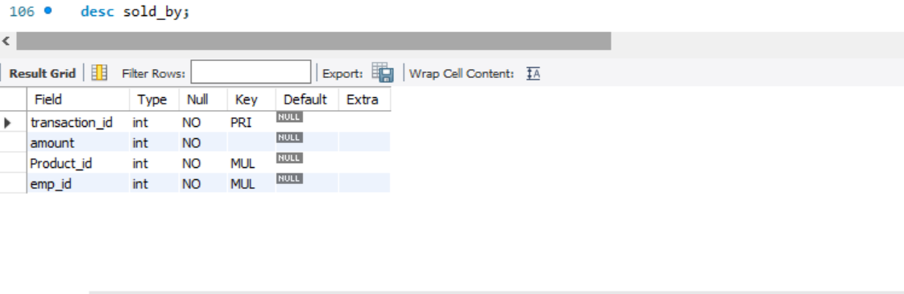

* Transaction_id:primary key
* Amount:the amount of product bought by customer in terms of money
* Product_id:the product sold;foreign key
* Emp_id:the employee who conducted the purchase;foreign key

Here the table satisfies the 3NF normal form As there are no partial dependencies or transitive dependencies. Multiple values do not exist. Also there exists transaction_id which is the candidate key for the table and all non-prime attributes are functionally dependent on it.note I added quantity here so that the score which is a derived attribute of the employee can be calculated which is nothing but .5% of the amount and so accordingly the employee can be awarded.

**B)THE WEBSITE**

**The Landing Page:**



There is landing page which will redirect the user to retrieve records of the company. When the user clicks on the ‘Step inside’ button then it will prompt them asking the key.The key has to be provided in order to access the database and if the key is wrongly entered then the window is going to close itself.

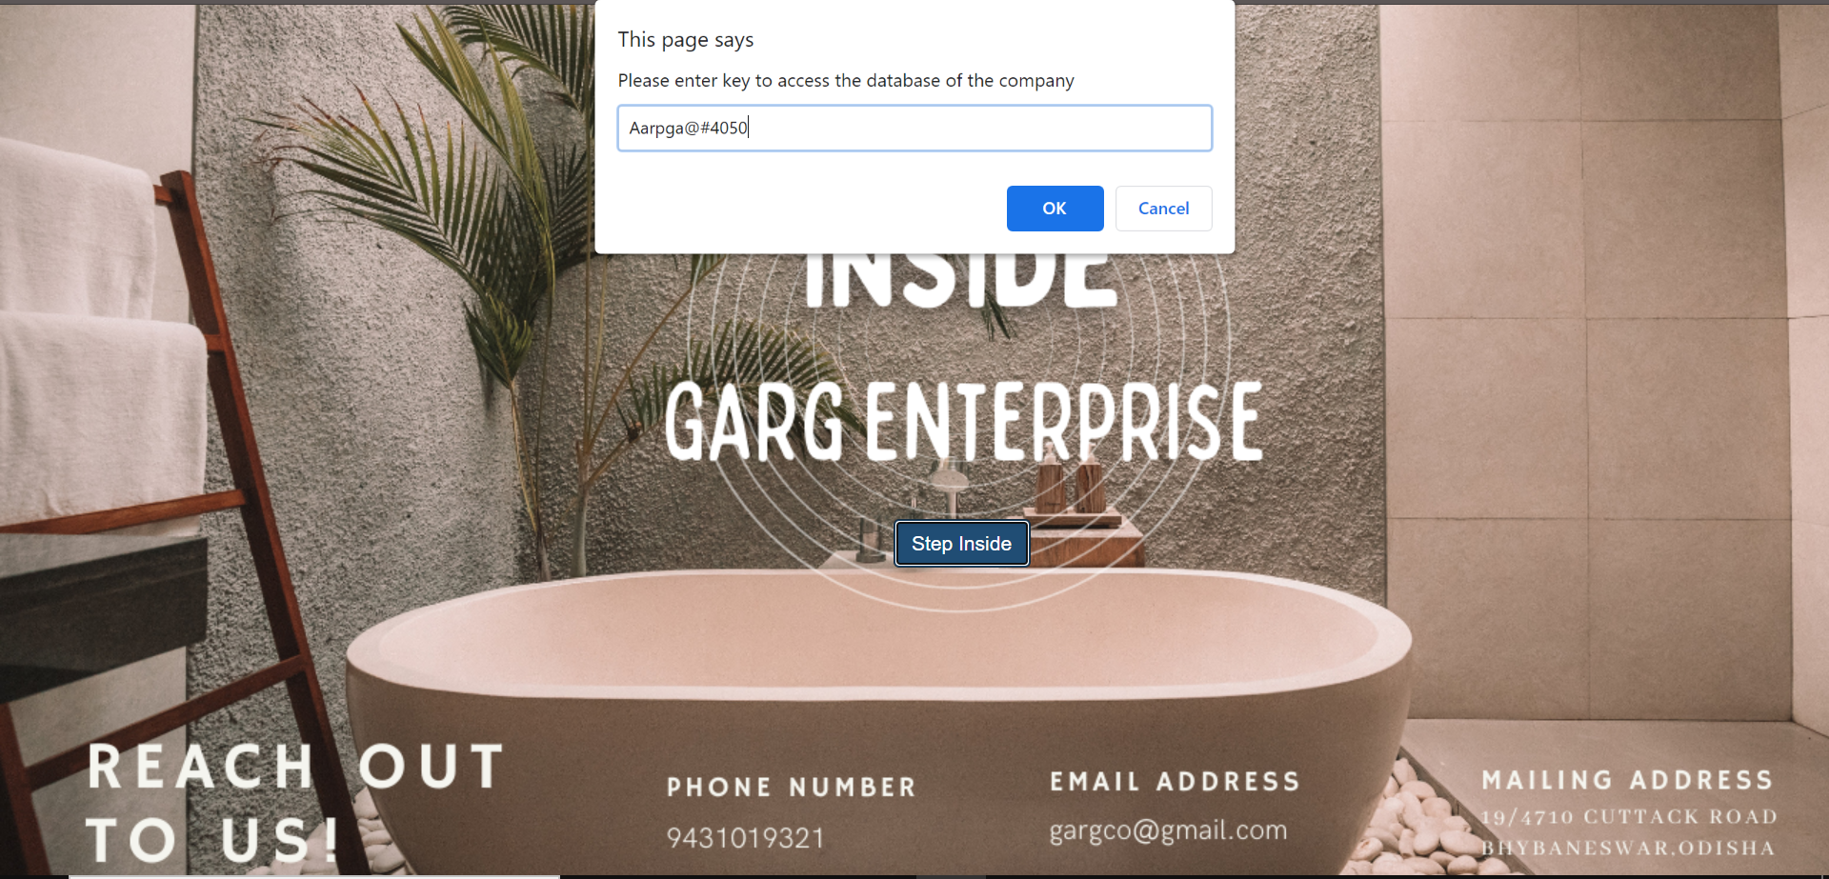

Here is the code for the landing page:

**<!DOCTYPE html>**

**<html>**

**<head>**

**<!-- Latest compiled and minified CSS -->**

**<link rel="stylesheet" href="https://maxcdn.bootstrapcdn.com/bootstrap/3.4.1/css/bootstrap.min.css">**

**<!-- jQuery library -->**

**<script src="https://ajax.googleapis.com/ajax/libs/jquery/3.5.1/jquery.min.js"></script>**

**<!-- Latest compiled JavaScript -->**

**<script src="https://maxcdn.bootstrapcdn.com/bootstrap/3.4.1/js/bootstrap.min.js"></script>**

**</head>**

**<body>**

**<button onclick="Inside()" id ="bt" type="button" class="btn btn-primary">Step Inside</button>**

**</body>**

**<style>**

**body {**

**background-image: url('garg.png');**

**}**

**#bt{**

**left: 625px;**

**top: 360px;**

**position: relative;**

**}**

**</style>**

**<script>**

**function Inside(){**

**var key = prompt("Please enter key to access the database of the company");**

**if (key.localeCompare("Aarpga@#4050")==0) {**

**location.href = 'http://localhost/myproject/back.php';**

**}else{**

**window.alert("Wrong key Entered");**

**window.close();**

**}**

**}**

**</script>**

**</html>**

**The Database Section:-**

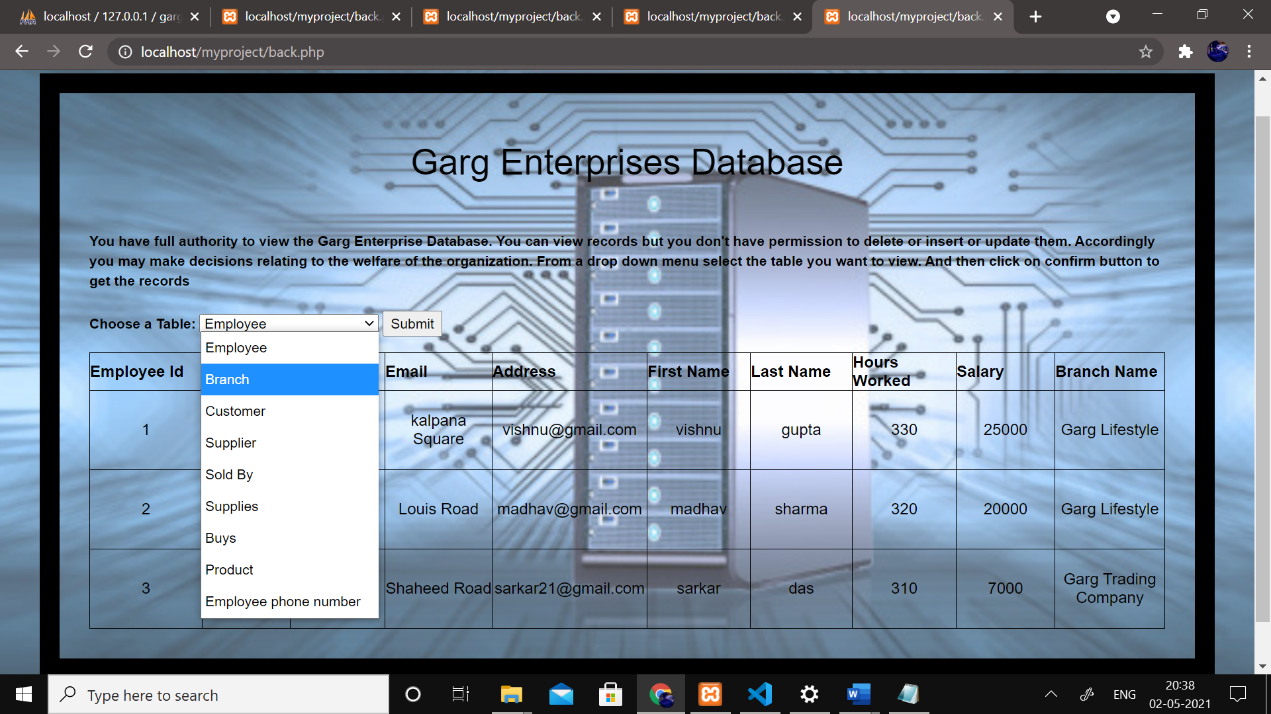

Here is the database section of the page. The user can oly access the database and doesn’t have the right to update , delete and insert tables. One person can be assigned to do this task and he can use the PHP admin of Xampp.I have posted screenshots related to all of them.The user selected ‘Employee’from the dropdown list table and could therefore see all the records of the Employee table.

Code of the same:-

**<html>**

**<head>**

**<!-- Latest compiled and minified CSS -->**

**<link rel="stylesheet" href="https://maxcdn.bootstrapcdn.com/bootstrap/3.4.1/css/bootstrap.min.css">**

**<!-- jQuery library -->**

**<script src="https://ajax.googleapis.com/ajax/libs/jquery/3.5.1/jquery.min.js"></script>**

**<!-- Latest compiled JavaScript -->**

**<script src="https://maxcdn.bootstrapcdn.com/bootstrap/3.4.1/js/bootstrap.min.js"></script>**

**</head>**

**<body>**

**<h1>Garg Enterprises Database</h1>**

**<p1></br></br><strong> You have full authority to view the Garg Enterprise Database. You can view records but you don't have permission to delete or insert or update them.**

**Accordingly you may make decisions relating to the welfare of the organization. From a drop down menu select the table you want to view.**

**And then click on confirm button to get the records</strong></br></br> </p1>**

**<form action="" method="post">**

**<label for="tables">Choose a Table:</label>**

**<select id="tables" name="tables">**

**<option value="Employee">Employee</option>**

**<option value="Branch">Branch</option>**

**<option value="Customer">Customer</option>**

**<option value="Supplier">Supplier</option>**

**<option value="Sold By">Sold By</option>**

**<option value="Supplies">Supplies</option>**

**<option value="Buys">Buys</option>**

**<option value="Product">Product</option>**

**<option value="Employee phone number">Employee phone number</option>**

**</select>**

**<input type="submit" name="submit" value="Choose options">**

**</form>**

**<?php**

**$servername = "localhost";**

**$username = "root";**

**$password = "";**

**$db="gargEnterprises";**

**// Create connection**

**$conn = new mysqli($servername, $username, $password,$db);**

**// Check connection**

**if ($conn->connect_error) {**

**die("Connection failed: " . $conn->connect_error);**

**}**

**if(isset($_POST['submit'])){**

**if(!empty($_POST['tables'])) {**

**$selected = $_POST['tables'];**

**if(strcmp("Employee",$selected)==0)**

**{**

**$sql = "SELECT * FROM Employee";**

**$result = $conn->query($sql);**

**if ($result->num_rows > 0) {**

**echo "<table>";**

**echo "<tr>";**

**echo "<th>Employee Id</th>";**

**echo "<th>Age</th>";**

**echo "<th>Birth Date</th>";**

**echo "<th>Email</th>";**

**echo "<th>Address</th>";**

**echo "<th>First Name</th>";**

**echo "<th>Last Name</th>";**

**echo "<th>Hours Worked</th>";**

**echo "<th>Salary</th>";**

**echo "<th>Branch Name</th>";**

**echo "</tr>";**

**// output data of each row**

**while($row = $result->fetch_assoc()) {**

**echo "<tr>";**

**echo "<td>" . $row['emp_id'] . "</td>";**

**echo "<td>" . $row['age'] . "</td>";**

**echo "<td>" . $row['birth_date'] . "</td>";**

**echo "<td>" . $row['address'] . "</td>";**

**echo "<td>" . $row['email_id'] . "</td>";**

**echo "<td>" . $row['first_Name'] . "</td>";**

**echo "<td>" . $row['Last_Name'] . "</td>";**

**echo "<td>" . $row['hoursworked'] . "</td>";**

**echo "<td>" . $row['Salary'] . "</td>";**

**echo "<td>" . $row['Branch_name'] . "</td>";**

**echo "</tr>";**

**}**

**}**

**else {**

**echo "0 results";**

**}**

**}**

**}**

**}**

**?>**

**</body>**

**<script type="text/javascript">**

**document.getElementById('tables').value = "<?php echo $_POST['tables'];?>";**

**</script>**

**<style>**

**body {**

**background-image: url('d1.png');**

**color: black;**

**padding: 30px;**

**margin: 40px;**

**border: 20px solid black;**

**}**

**td {**

**height: 80px;**

**width: 160px;**

**text-align: center;**

**vertical-align: middle;**

**}tr:hover {background-color: white;}**

**table, th, td {**

**border: 1px solid black;**

**}**

**h1{**

**text-align: center;**

**}**

**</style>**

**</html>**

**PHP MYADMIN:-**

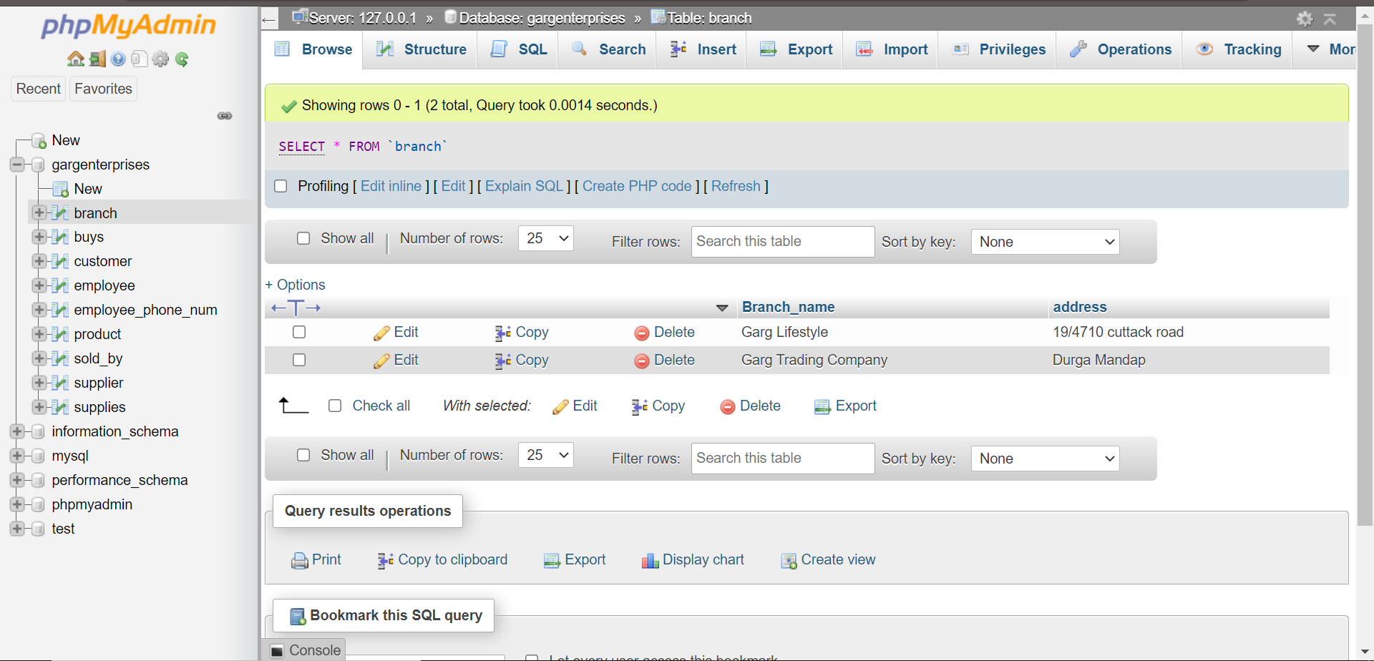

You can clearly see all the tables we had created in MySQL. I just imported that file in here. And the GUI is very simple. The data Admin can easily inser , delete and update tables from here by clicking on the desired icons.

**XAMPP Control pannel:**

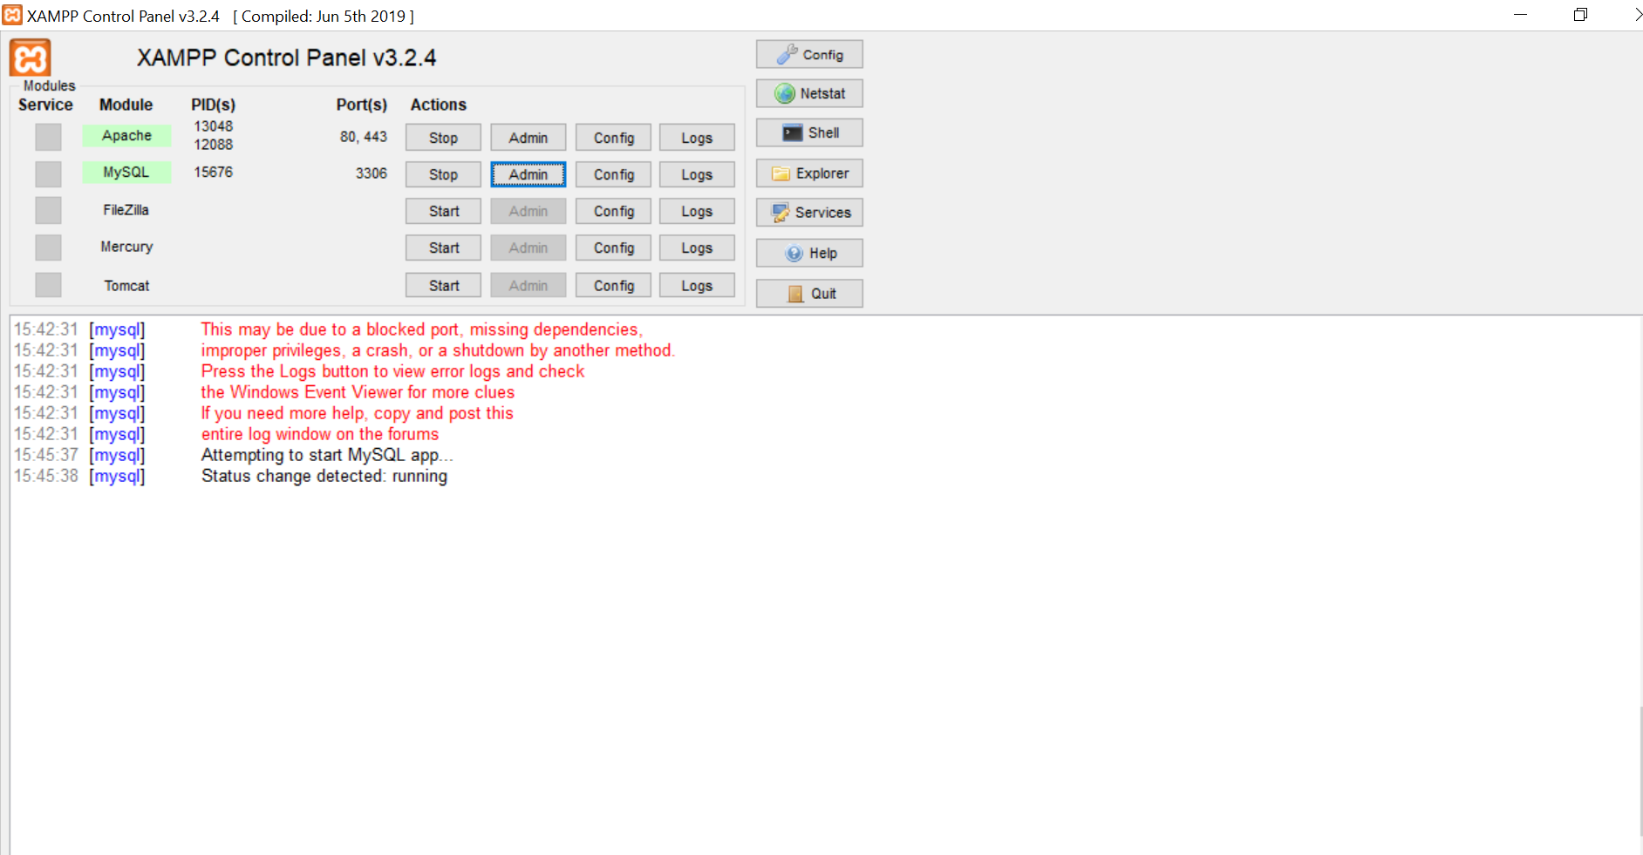

So I had used apache to crate a local host and enabled MySql so as to connectmy PHP code with SQL database

**CONCLUSION**

Because of the very limited time, I was unable to fully finish implemented all the functionalities, but I have set up the perfect structure, and I just have to keep on adding the functionalities here. But I have successfully finished implementing the database based on MySQL completely, and a lot of core functionalities of the website. Similarly we may even create the search by interface in the website by just adding the related query in the PHP section .The idea is to build a comprehensive, fully functioning Company website. I’d like to thank our professor for his due guidance in this project, and throughout the course.

**DECLARATION**

I hereby declare that the project entitled **“*_Registrar+*___**” submitted as part of the partial course requirements for the course _***WEB TECHNOLOGY***  for the award of the degree of Bachelor of Technology in Computer Science Engineering at Manipal University Jaipur during the _***2nd May 2021*** semester, has been carried out by me. I declare that the project has not formed the basis for the award of any degree, associate ship, fellowship or any other similar titles elsewhere.

Signature of the Student:

*Pradumn garg*

Place:

19/4710 Garg Trading Company Old Station Road

Bhubaneswar-751006

Date:12/05/2021

**BIBLIOGRAPHY**

<https://www.youtube.com/watch?v=o1IaduQICO0&t=2746s> – JavaScript

<https://www.youtube.com/watch?v=CMk8xB90RpU-Bootstrap>

<https://www.youtube.com/watch?v=hx38tnlYGlA-PHP>

<https://www.coursera.org/learn/sql-for-data-science-MySQL>

<https://www.youtube.com/watch?v=-f8N4FEQWyY-XAMPP>

<https://www.youtube.com/watch?v=3_9znKVNe5g>-CSS

<https://www.youtube.com/watch?v=ZsEmD-kRQ3M-HTML>

<https://www.w3schools.com/-Code> Snippets

The above sites helped me a lot to learn about full stack web development and helped me creating this site from scratch.